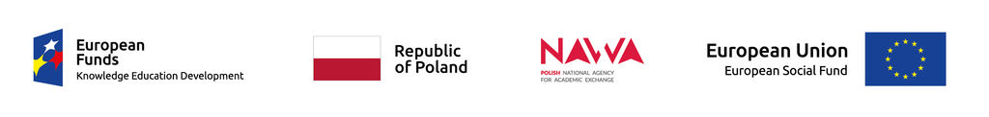
Recruitment results for arrivals at the Wrocław University of Economics during the Prom Program:

Ph.D. students:
Application no. Type of activity
1 PZ/D/01 5-days visit for participation in scientific consultations
2 P2/D/02 10-days visit for obtaining materials, carry out measurements
3 P2/D/04 5-days visit for participation in scientific consultations
4 P2/D/05 10-days visit for obtaining materials, carry out measurements
5 P2/D/06 5-days visit for participation in scientific consultations
6 P2/D/07 10-days visit for obtaining materials, carry out measurements

Academic Staff Member:
Application no. Type of activity
1 PZ/ASM/02 5-days visit for participation in scientific consultations

Lectures for Summer School:

Application no. Name of the course
1 PZ/L/02 Conceptual framework of PhD thesis
2 PZ/L/04 How to get published in good journals
3 PZ/L/07 Mixed methods research design & analyses

Candidates were qualified by the principles of equal opportunities and non-discrimination within the meaning of the Guidelines for the implementation of the law of equal opportunities and non-discrimination, including accessibility for people with disabilities and the principle of equal opportunities for women and men as part of EU funds for 2014-2020.
The qualified participants will be informed by e-mail about further steps related to the trip.
In case of any doubts, please contact us:
cobn@ue.wroc.pl

