

www.eu2010.es
Presidencia española de la Unión Europea
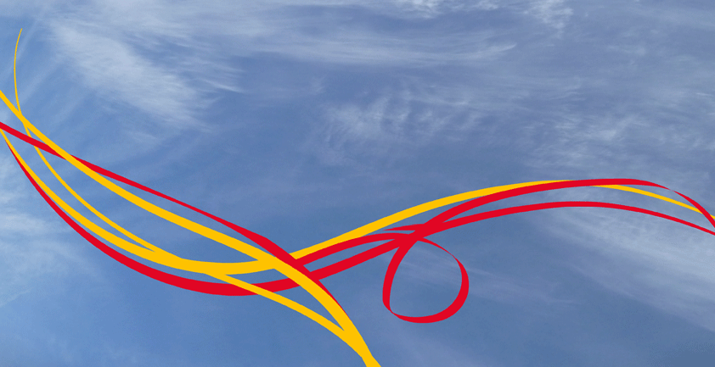
PRACTICAL INFORMATION

Entrepreneurial Universities: New Models.

Santiago, March 22-23

Universidad de Santiago, Spain, March 22-23

1.- Registration.

Please register by sending an e-mail to EU@educacion.es, no later than 13 March. If there are any problems, please contact us at this e-mail. Participants are signed at the Conference venue, Fonseca College, (Fonseca Square, 15782 Santiago de Compostela), Monday March 22 from 10,30. There will be a specific registration desk at the entrance of the College, in order to facilitate early registration and handing over the materials for the meeting.

2.- Visas.

A visa is required for participants from countries other than those belonging to the European Union or any of the following countries: Andorra, Argentina, Australia, Brazil, Brunei, Canada, Chile, Costa Rica, El Salvador, The United States, Guatemala, Honduras, Iceland, Israel, Japan, Liechtenstein, Malaysia, Mexico, Monaco, Nicaragua, Norway, New Zealand, Panama, Paraguay, Republic of Korea, San Marino, Vatican City State, Singapore, Switzerland, Uruguay, Venezuela , special regions in China, and Macao. Further information about entry visas can be obtained from the following website:
http://www.maec.es/en/MenuPpal/Consulares/ServiciosConsulares/InformacionaExtranjeros/Paginas/REQUIREMENTSFORENTRY.aspx
Spain has an extensive network of Consulates and Embassies abroad that provide a series of services. The Spanish mission abroad will provide more detailed information on visa processing. Please find relevant contact information at:
http://www.maec.es/en/EYC/Paginas/embycon.aspx
http://www.visados.es/Paises_SIN_Visado.php

3.- How to get there.
Santiago de Compostela is located in the northwest corner of Spain, only a few kilometers inland from continental Europe’s westernmost coastline, in the region now called Galicia, which de Romans considered the end of the earth (Finis terrae).

Santiago de Compostela is world renowned as the final destination of a thousand-year-old pilgrimage route: the Way of St. James, which, startin from the 9th century, has transformed this Land’s End into a meeting place of Western faith and thinking.

Today, Santiago is the cultural and political capital of Galicia, one of Spain’s 17 Autonomous Regions.
By plane:

Santiago de Compostela Airport
Lavacolla (10 km from city centre; 15 min by car)
Tel: (+34) 981 54 75 00 / (+34) 981 54 75 01
Flight times and updated information on web www.aena.es

Companies operating out of Santiago Airport:
Iberia www.iberia.com
Spanair www.spanair.com
Air Europa www.aireuropa.com
Air Nostrum www.airnostrum.es
Plaza www.plazaserviciosaereos.net
Ryanair www.ryanair.com
Air Berlin www.airberlin.com
Vueling www.vueling.com
Aer Lingus www.aerlingus.com
Clickair www.clickair.com
Aerolineas Argentinas www.aerolineas.com

3. Transport to/from the airport.
Participants are asked to make their own travel arrangements. Santiago de Compostela airport is ten kilometers northeast of the city. The city center can be reached by, bus or taxi.
Airport bus: Continuous service between the city centre and the airport operated by Company Freire, www.empresafreire.com .
Special Ryanair bus service: for the convenience of Ryanair passengers, the company’s flights have a special bus servce with departures adapted to flight times.
Taxi: Taxis can be found outside the Arrivals Hall. There is a standard taxi fare from the city centre to the airport (approximately €18).

6.- Accommodation.
Rooms have been reserved at three hotels, subject to confirmation of booking by the participants no later than 13 March.

HOTEL NH OBRADOIRO*****
Av Burgo das Nacions s/n
15705, Santiago de Compostela
España
TEL. +981 55 80 70
FAX. +981 57 51 56
nhobradoiro@nh-hotels.com
www.nh-hotels.com

HOTEL COMPOSTELA****
C/ Hórreo no 1 - 15701 Santiago de Compostela
No telf..: 981 585 700
No fax..:981 576 373
e-mail: reservas@hotelcompostela.es
web.: www.hotelcompostela.es

HOTEL SAN FRANCISCO****
Campillo San Francisco, 3
15705 Santiago de Compostela
A Coruña, España
Tel. 00 34 981 55 48 84
reservas@sanfranciscohm.com
www.sanfranciscohm.com
PLEASE, STATE "ENTREPRENEURIAL UNIVERSITIES-USC", WHEN YOU ASK FOR YOUR BOOKING.

The Ministry of Education of Spain and the University of Santiago will cover one night (22 March).

Any additional stay must be covered by the sending organization or by the attendant.

7.- Meals.
Breakfast is offered at the hotels and included in the price. Lunch and dinner are covered by the organization.

8.- Social program

Visit to the University heritage
From the eldest colleges and libraries to the amazing views of the city that one can contemplate at the top of the Faculty of Geography and History, the programme of visit to the Heritage of the University of Santiago de Compostela allows to perform a guided visit through the most emblematic university spaces within the old village.

Santiago de Compostela Walking tour:
Obradoiro Square (Catholic ́s Kings Hospital, Raxoi Palace, San Fructuoso Churc.).
Outside Catedral: Platerias Square (Treasure Façade & Cabildo's Palace), Quintana Square (San Paio de Antealtares Convent, Casa de la Conga, Casa de &Holy Door), Azabachería Square (Corticela Chapel& San Martín Pinario Monastery). Walking tour through the "Rúas" (picturesque and narrow streets) admiring the "Pazos" (urban Manor House).

9.- Entrepreneurial at USC
THE ENTREPRENEURSHIP PLAN OF THE UNIVERSITY OF SANTIAGO DE COMPOSTELA (UNIEMPRENDE)

http://www.uniemprende.es

10.- Tourist information

SANTIAGO DE COMPOSTELA
The following web site provides all the information about the city: accommodations, restaurants, places to visit, stores etc. If you are looking for an in-depth view of the city, guided tours around the city are also available in different languages.
www.santiagoturismo.com

LUGO
The University of Santiago has also a Campus located in the city of Lugo.
You can find information about the city on this web page.
http://www.lugoturismo.com/?idioma=i&

TURGALICIA
The web site offers lots of information about Galicia in general: places to visit: natural and cultural heritage, accommodations, transportation, etc.
www.turgalicia.es/default.asp?cidi=I

XACOBEO, HOLLY YEAR AND WAY OF SAINT JAMES
In the web site, there is a lot of information about each route: accommodations, all the stages, kilometres of each stage, and the cultural program about the Holy Year 2010.
www.xacobeo.es/en
11.- Miscellaneous.

Spain has adopted the euro. Credit cards (VISA, MasterCharge, American Express) are generally accepted.

The electric current is normally 220 V. You may need an adapter to plug in laptops or other electrical appliances.

For more information:
www.spain.info

The organizers wish you a productive and enjoyable meeting in Santiago!

