www.eu2010.es
Presidencia española de la Unión Europea
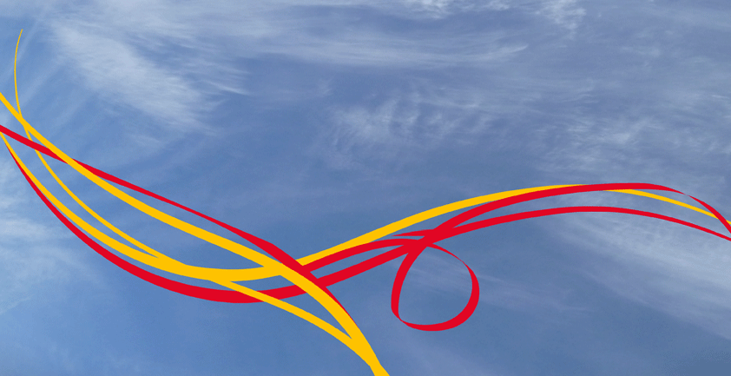
PROVISIONAL PROGRAMME

Internationalization of Higher Education. A foresight exercise for 2020 and beyond. Universidad Complutense de Madrid

Madrid, April 19 - 20

Monday, 19 April

09:00 - 9:30 Arrival of participants
Welcome coffee

OPENING SESSION. Anfiteatro Ramón y Cajal

09:30 – 10:00 Spanish Minister for Education (tbc)
Commissioner of Education (tbc)
Rector of University Complutense of Madrid

PLENARY SESSION 1. Anfiteatro Ramón y Cajal

10:00 – 10:30 European Higher education in a globalising world

Speaker: Mr Frans van Vught, President European Centre for Strategic Management of Universities (ESMU)

10:30 – 11:00 Internationalisation of Higher Education: The Spanish strategy

Speaker: Mr José Manuel Martínez Sierra, Director General of International Affaires, Ministry of Education. Spain

11:00 – 11:30 Coffee Break

11:30 – 13:00 Workshop 1:

Global Mobility and collaboration in teaching and research

Chair: Ms Barbara Nolan, DG EAC European Commission
Speakers: Mrs Fiona Hunter, former president EAIE
Mr Bernd Waechter, Secretary General ACA
Mr. Lawrence Pitts, Executive Vice President University of California
Debate

13:00 – 14:30 Lunch

14:30 – 16: 30 Workshop 2:

Higher Education and the global labour market

Chair: Mr Jan Pakulski, DG EAC European Commission
Speakers: Mr Wayne Johnson, vice president HP, USA Mr Peter Gaehtgens, former rector of the Free University of Berlin,
Mr Carlos Torres, UCLA
Debate

16:30 – 17:00 Break

17:00 – 19:00 Round Table: Anfiteatro Ramón y Cajal

Instruments for the internationalisation of higher education

Moderator: Mr Jordi Curell (DGEAC, EC)

Speakers: Ms Barbara Weitgruber, BMWF, Austria.
Mrs Marijk van de Wende, Dean Amsterdam University College
Miss Nina Lemmens, DAAD, Germany

Debate

19:00 Welcome reception. Spanish Wine & Tapas

Tuesday, 20 April

09:00 – 09:30 Trends in the internationalisation of higher education
Mr Simon Marginson, Melbourne University

09:30 – 11:00 Workshop3: Higher Education models in the world

Chair: Mr Juan Gimeno, President CEURI

Speakers: Mr Bernd Huber, President Ludwig Maximilian University, Munich
Ms Irina Khaleeva, Rector State University Moscow
Mr Orlando Quilambo, U. Eduardo Mondlane, Mozambique
Mr. Luis Aragón, Universidad Federal do Para, Brazil

Debate

11:00 – 11:30 Coffee Break

11:30 – 13:00 Round Table. Anfiteatro Ramón y Cajal

Moderator: Mr. Luis Delgado, Spanish Presidency
Speakers: the Chairpersons of the three workshops: Presentation of the conclusions from each workshop
Debate

13:00 – 14:00 New avenues for international cooperation in higher education at a global scale

Speakers: Mr. Young-Gil Kim, President Handong Global University
Mr. Jean Marc Rapp, President EUA

CLOSING SESSION

14:00 – 14:30 Mr Màrius Rubiralta, Secretary General of Universities, Spain
Ms. Odile Quintin, Director General of Education, European Commission
Rector of University Complutense of Madrid (tbc)

14:30 Closing Lunch

