ACCOMODATION
Our University has two dormitories in which we can accommodate Erasmus students – “Ślężak” and “Przegubowiec”.

DORMIOTRY “ŚLĘŻAK”
Address: ul. Ślężna 33, 53-301 Wrocław
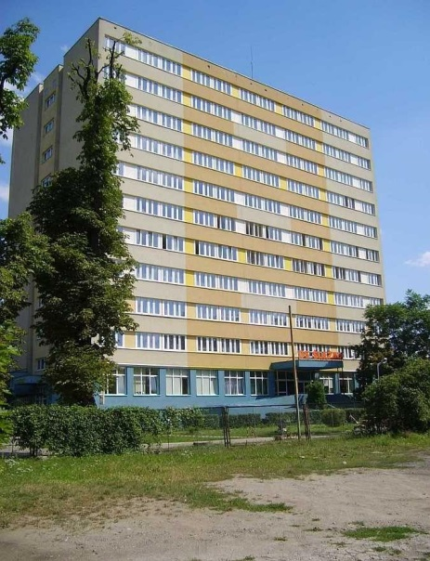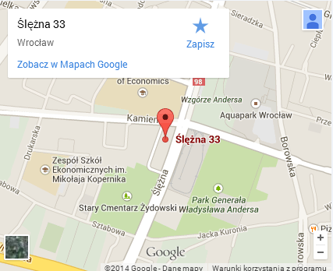

All floors are divided into modules consisting of 2 rooms (one double and one triple) with one bathroom for both rooms. Rooms are furnished (bed, table, wardrobe, chairs) also the bed lines are provided. On each floor there is one communal kitchen which can be used by all students.
Prices of rooms:
Double room: 400 PLN
Tripple room: 380 PLN
The rent is paid monthly up till 10th day of each month. Upon your arrival you will be additionally charged a deposit (equal one-month rent). The deposit will cover your last full month in the dormitory.

DORMIOTRY “PRZEGUBOWIEC”
Address: Kamienna 35/37, Wrocław
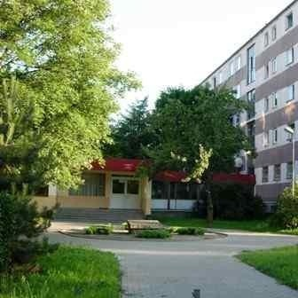
Only double rooms are available. Each room has its own bathroom and little kitchen. Rooms are fully furnished and bed lines are provided.
Prices of rooms:
Double room: 500 PLN

The rent is paid monthly up till 10th day of each month. Upon your arrival you will be additionally charged a deposit (equal one-month rent). The deposit will cover your last full month in the dormitory.
In order to reserve a room you have to compete the recruitment process and send all required application documents. Please do not forget to tick an appropriate field in the Application Form. Also you have to fill your arrival confirmation and send it back either by fax +48 71 36 72 784 or
e-mail anna.lopatowska-rybak@ue.wroc.pl till 10th of July for the winter semester/ academic year and 10th of December for the summer semester). Without this arrival confirmation your reservation will be cancelled.

!!! Please be aware of the fact that the number of places in the dormitory is limited and we are not able to provide accommodation for all students, so the faster you send your application documents the bigger chance you have to get a room. ONLY full application documents will be considered (Application Form, Transcript of Records and Learning Agreement + online application form) The final list of students with a place in the dormitory will be given at the end of June.

