The project is supported by: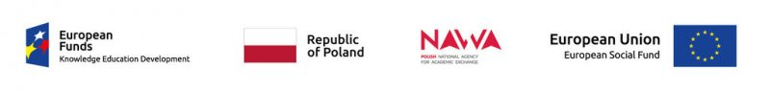

Results of second recruitment for arrivals at the Wrocław University of Economics during the Prom Program:

Ph.D. students:
Application no. Type of activity
1 PZ2/D/03 5-days visit for participation in scientific consultations
2 PZ2/D/02 10-days visit for obtaining materials, carry out measurements
3 PZ2/D/01 10-days visit for obtaining materials, carry out measurements

Candidates were qualified by the principles of equal opportunities and non-discrimination within the meaning of the Guidelines for the implementation of the law of equal opportunities and non-discrimination, including accessibility for people with disabilities and the principle of equal opportunities for women and men as part of EU funds for 2014-2020.
The qualified participants will be informed by e-mail about further steps related to the trip.
In case of any doubts, please contact us: cobn@ue.wroc.pl

