Instruction for getting access to syllabuses for Master and Bachelor courses provided in English
The link to the program is as follows: https://ue.e-sylabus.pl/forStudents
Some of the content is in English, however the headers and selection lists are all in Polish and, therefore, the instruction is meant to help you navigate.
When you click on the above link, you will see the following screen:
You click here to choose your academic year from the list.

Then, you choose from the three faculties based in Wrocław:
Inżynieryjno-Ekonomiczny – Engineering and Economics
Nauk Ekonomicznych – Economic Sciences
Zarządzania, Informatyki i Finansów – Management, Computer Science and Finance
DO NOT choose the faculty which is the first one on the list (highlighted in blue), as it is not based in Wrocław.

By clicking here you open the list of majors. You can choose from those available in English.
The next thing you choose is the form of study:
I stopień – Bachelor course
II stopień – Master course
III stopień – PhD course

After choosing the course type you just click on ‘Przejdź’ (Go to).

You will see the following table:

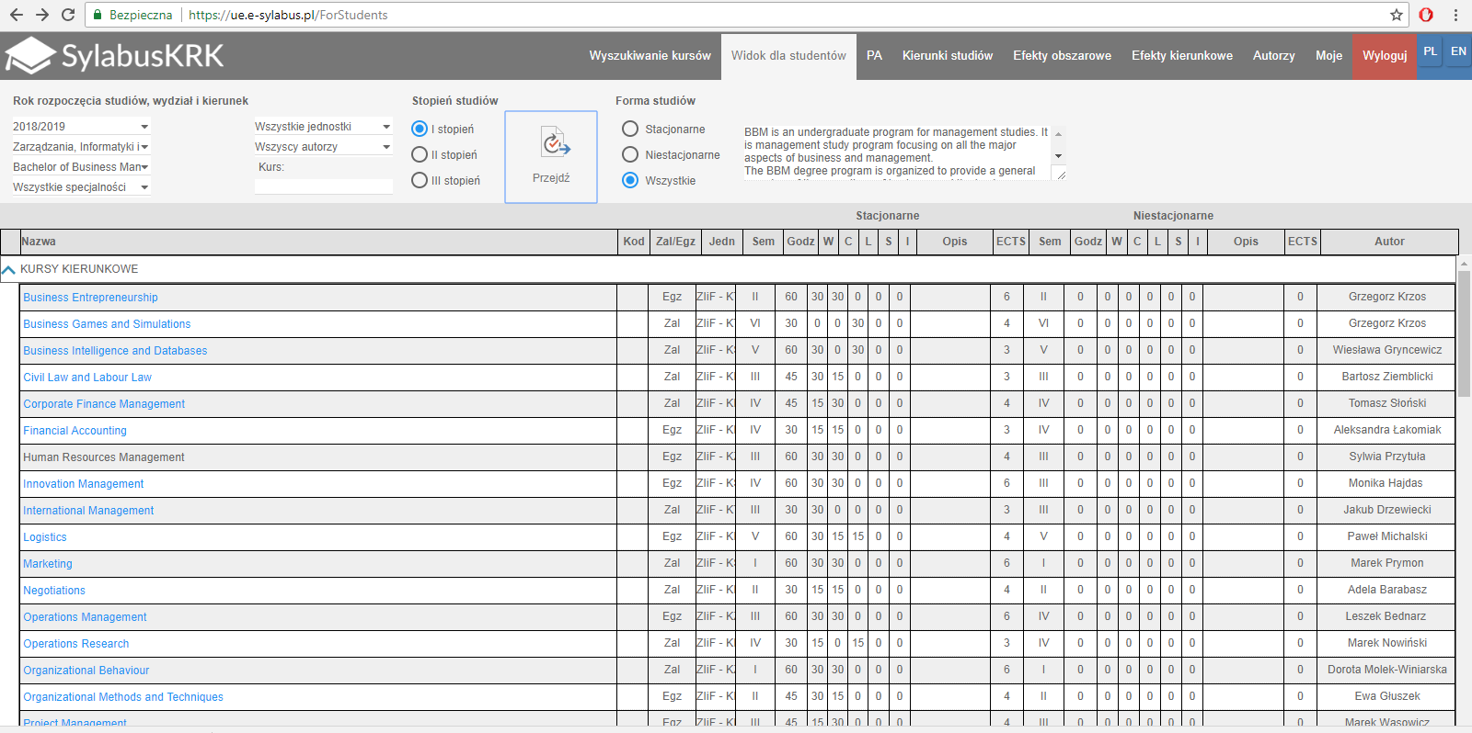

For the courses in blue you can edit their syllabuses by clicking on them. The courses in black are still to be updated by lecturers, so you should check this table from to time to see if they can be viewed.

You will see the following content (it takes some time before it uploads):

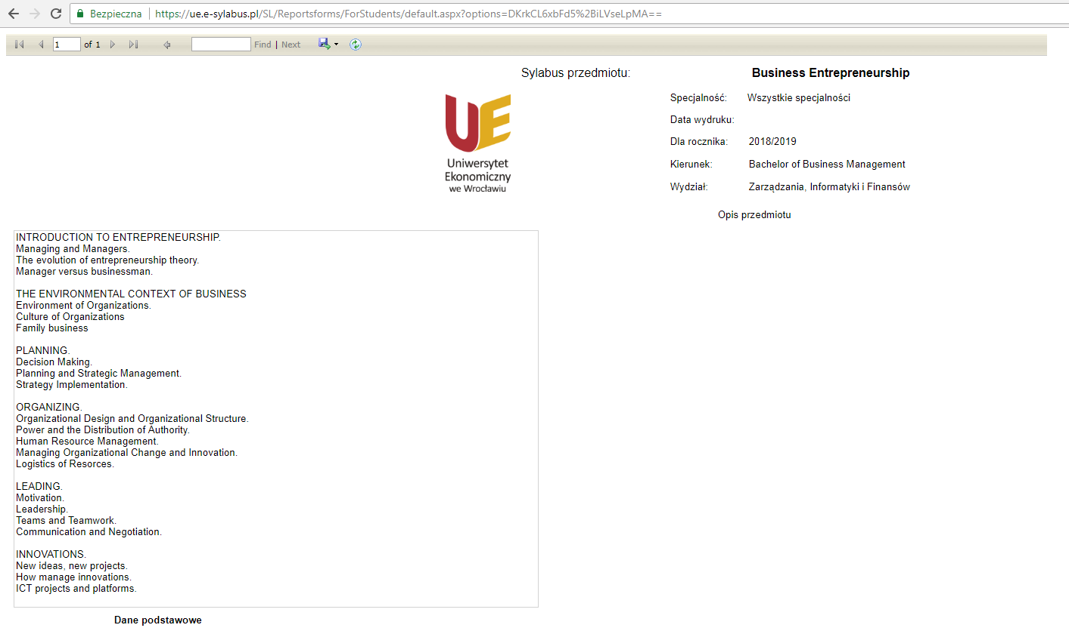

You will see that some of the courses have only the content in Polish and some of them have already the course description in English. This service in its English version is still under development, so the content will be gradually added.

