 | Internal Document of IT Center, Wroclaw University of Economics
MANUAL
Regarding | How to use the Timetable
Version number | 01/03/2023
In force from | 01/03/2023
Prepared by | Katarzyna Kozioł
Approved by | [full name]
Date of preparation | 16/01/2023

MANUAL FOR STUDENTS – HOW TO USE THE TIMETABLE

Table of contents
Document purpose 3
General information 3
Terms of access to the system 3
System symbols and abbreviations 3
Types of activities used in the system 5
Grid views for study programmes 5
View of the SJO timetable 7
View of the SWFiS activity grid 8
View of the Erasmus activity grid 8
Additional views in the timetable 10
How to print the timetable 11

Document purpose
The purpose of the document is to provide information on how to check the planned Timetable using the timetable system.

General information
The timetable contains information about the timetable of scheduled classes at UEW for students of the faculties taught in Wrocław. Access to the system does not require logging in.

Terms of access to the system
The timetable is available on the website at plan.ue.wroc.pl. You can also access it via the homepage of UEW ue.wroc.pl (Fig. 1).
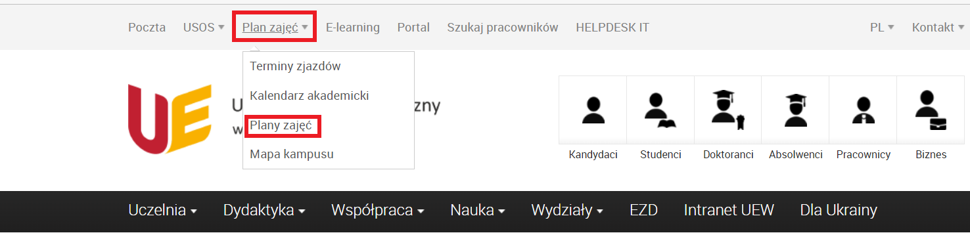Fig. 1
The timetable is displayed as a drop-down list located in the left-hand side panel (Fig. 2).
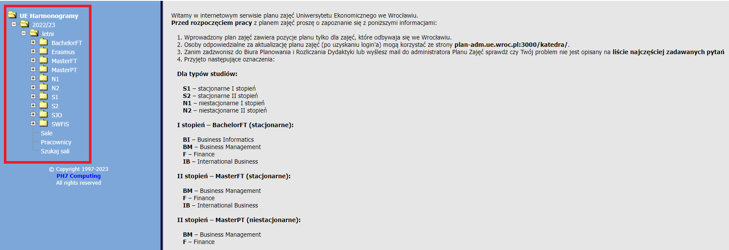Fig. 2

System symbols and abbreviations
- Designation 2022/23 – academic year;
- letni/zimowy – summer/winter term designation;
- Types of study for courses taught in English:
BachelorFT – full-time undergraduate studies;
Erasmus – for Erasmus students;
MasterFT – full-time second cycle studies;
MasterPT – part-time second cycle studies
- Types of study for courses taught in Polish:
S1 – full-time first degree;
S2 – full-time second degree;
N1 – part-time first degree;
N2 – part-time second degree,
- SJO – Foreign Language Study plan.
- SWFiS – Physical Education and Sport Study plan.
A detailed calendar of activity dates is indicated by the symbols: (Fig. 3)
T1 – first half of the semester;
T2 – second half of the semester.
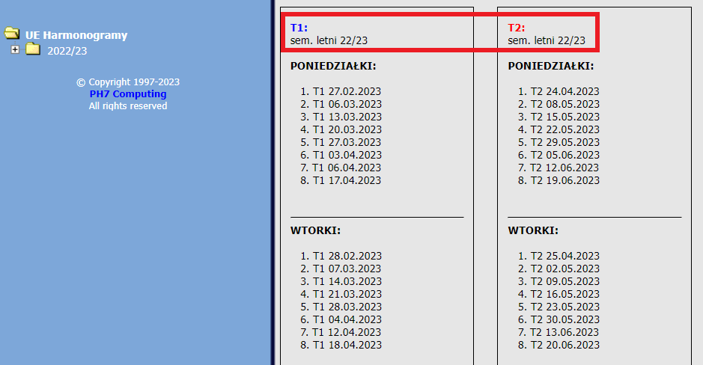Fig. 3
Course symbols used in the course schedule:
AG – Economic analysis
BI – Business Informatics
BM – Business Management
EK – Economics
F – Finance
FIR – Finance and Accounting
GP – Spatial Management
IB – International Business
IWB – Information Technology in Business
KPG – Legal and Economic Consultancy
LG – Logistics
MSG – International Economic Relations
RIC – Accounting and Controlling
ZA – Governance
ZIIP – Production Management and Engineering

Explanation of sample group and subject codes used in the timetable:
e.g. group D2-S1 01 FIR – year of study “2”, mode and type of study “ stacjonarne I stopnia”, group number “01”, field of study “Finance and Accounting”
e.g. group M1-N2 02 MSG – year of study “1”, mode and type of study “niestacjonarne II stopnia”, group number “02”, major “International Economic Relations”.
subject – RAF-(N) 112A – subject abbreviation “Financial Accounting”, full semester classes “N”, room number and building “112A”
subject – ST-(T1) 109Z- subject abbreviation “Statistics”, classes in the first half of the semester “T1”, room number and building “109Z”

Types of activities used in the system
W – lecture: activities displayed in blue in the schedule;
Ć – exercises: activities displayed in green in the schedule;
L – laboratories (laboratory exercises): activities displayed in red in the schedule;
JO – foreign language classes: displayed in grey in the schedule.

Grid views for study programmes
The view of scheduled activities is displayed by selecting the data of interest from the drop-down list. The data grid window can be viewed by day, group, and hour. By default, for full-time students, the view by day is displayed. (Fig. 4) For part-time studies, the default view is by meeting date.
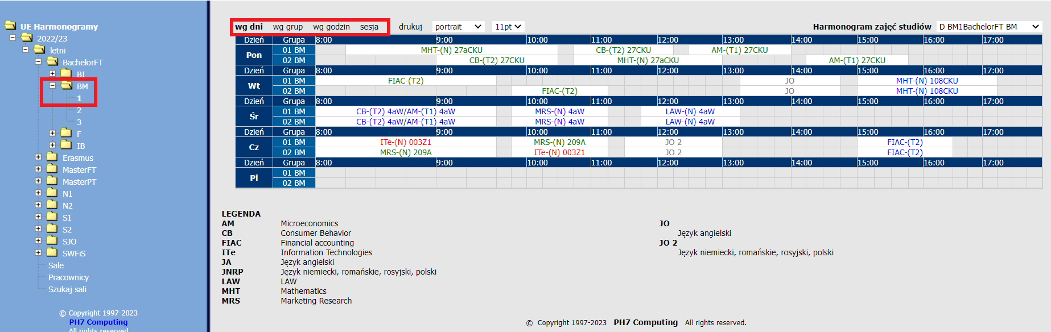Fig. 4

The grid view displayed by group and by hour uses the filter in the top right corner to select a specific group. (Fig. 5)
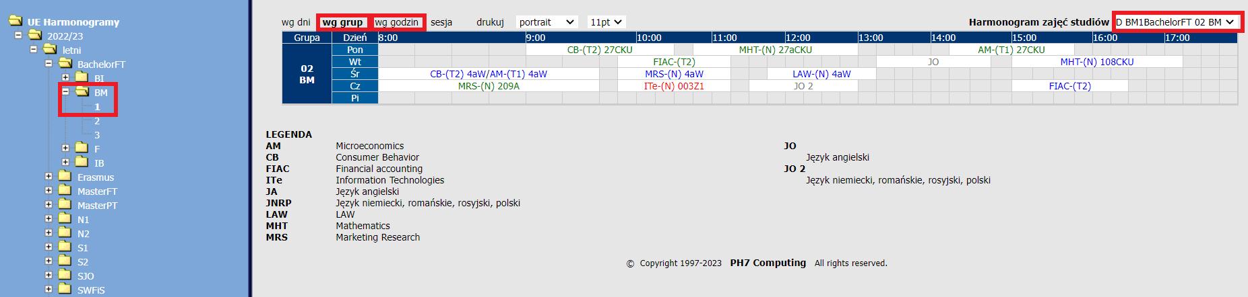Fig. 5
On the activity grid, individual activities are colour-coded. Click on the desired subject to display a new window with the dates broken down into specific meetings. (Fig. 6)
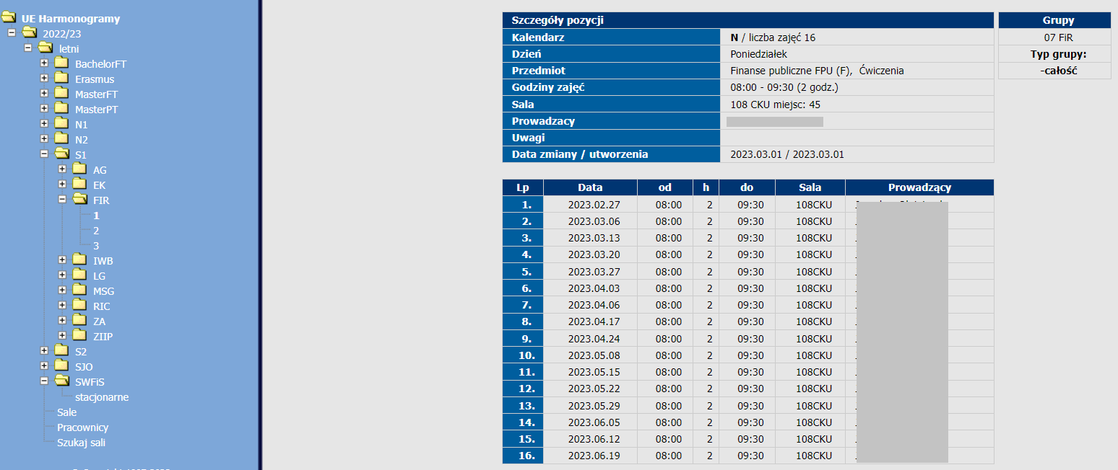Fig. 6
Click on “lista” in the top panel and select a particular group to display the timetable view as shown below. (Fig. 7)
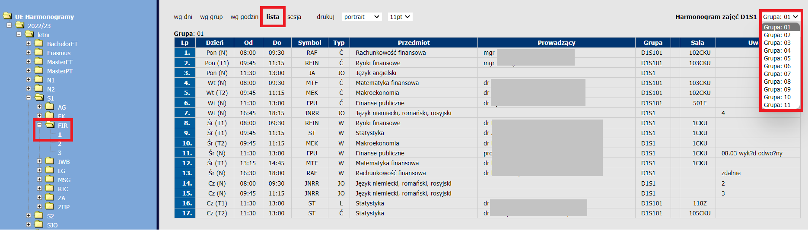Fig. 7

From this level, it is also possible, using the “sesja” view, to display information about the planned dates and locations of examinations and credits. (Fig. 8)
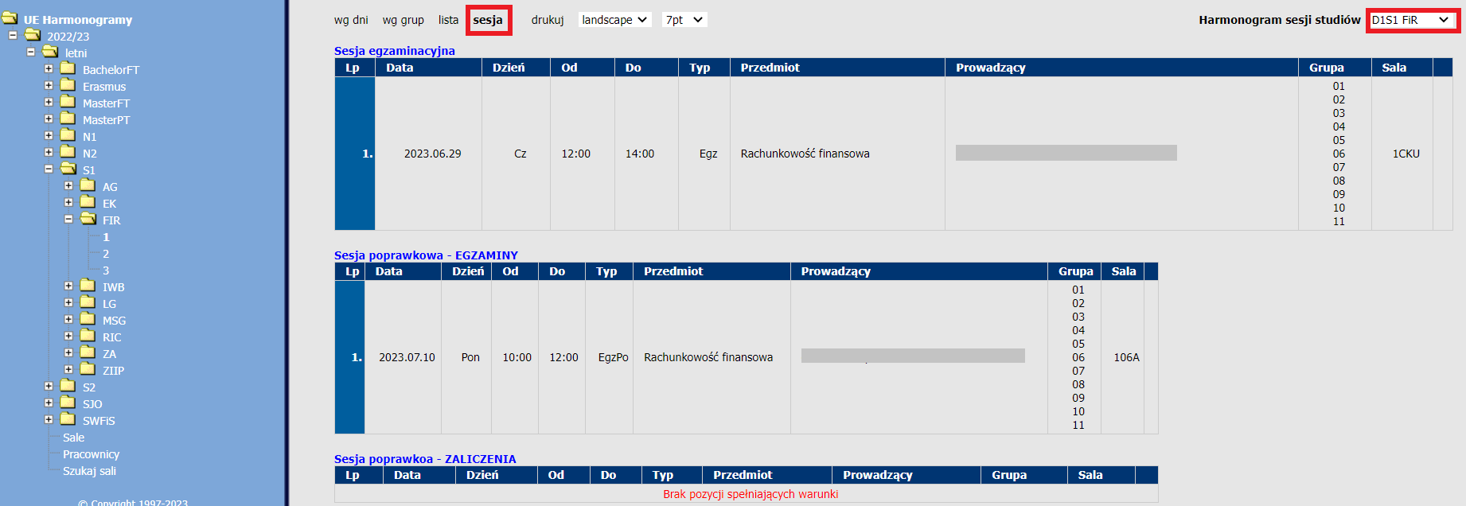Fig. 8

View of the SJO timetable
The classes of the Foreign Language Study are displayed by mode and type of study and year of study. The schedule can be viewed by day, group and hour. Language groups are displayed by field of study. (Fig. 9)
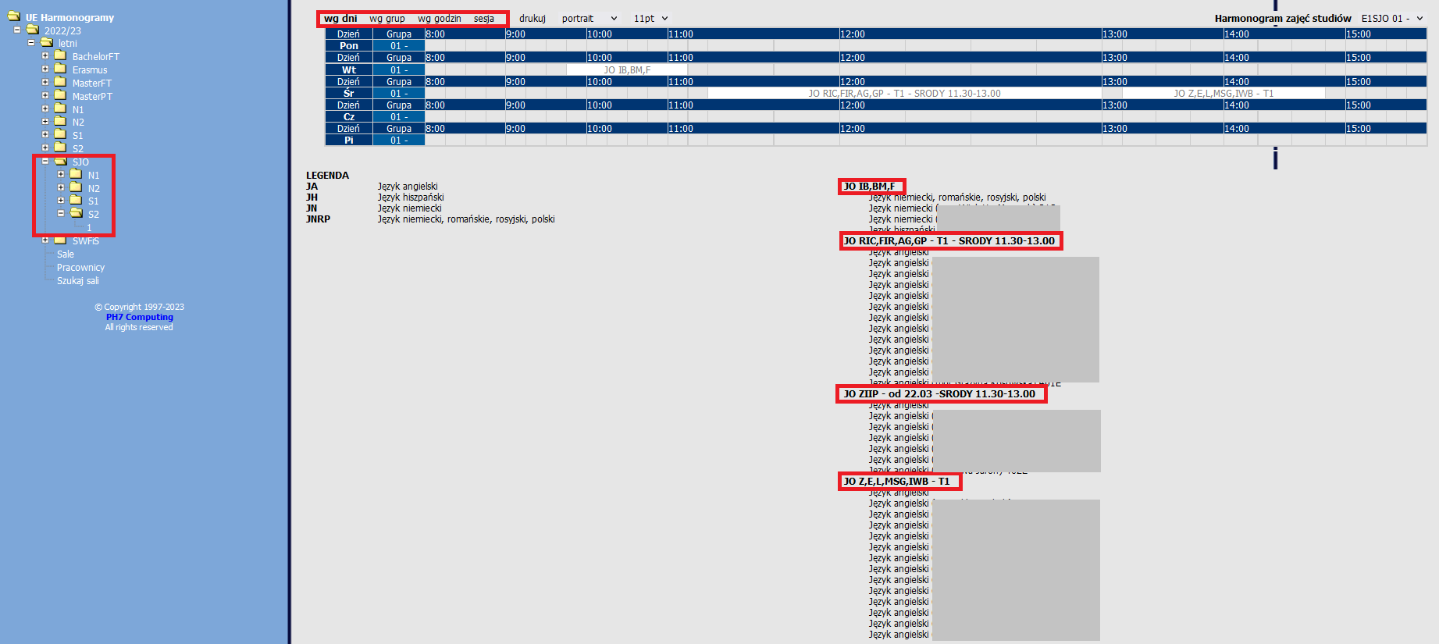 Fig. 9

View of the SWFiS activity grid
The view of the schedule of the Physical Education and Sports Study can be displayed in different configurations, by day, instructor, and room. (Fig. 10)
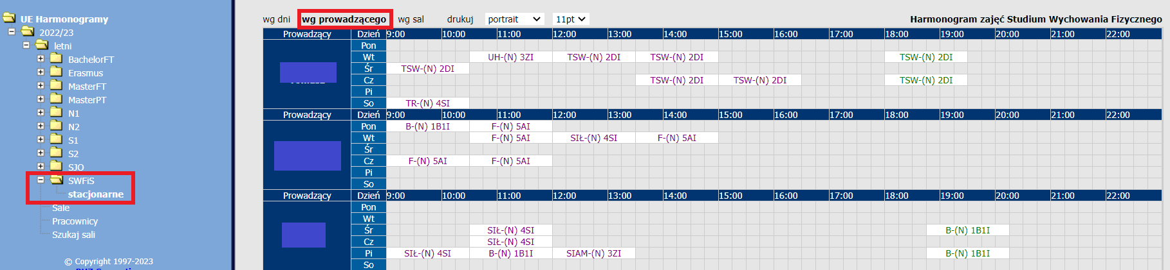 Fig. 10

View of the Erasmus activity grid
Erasmus students can view the grid of individual subjects by day and groups. The schedule is available by selecting “Erasmus – ERA – 1” from the side panel on the left. (Fig. 11)

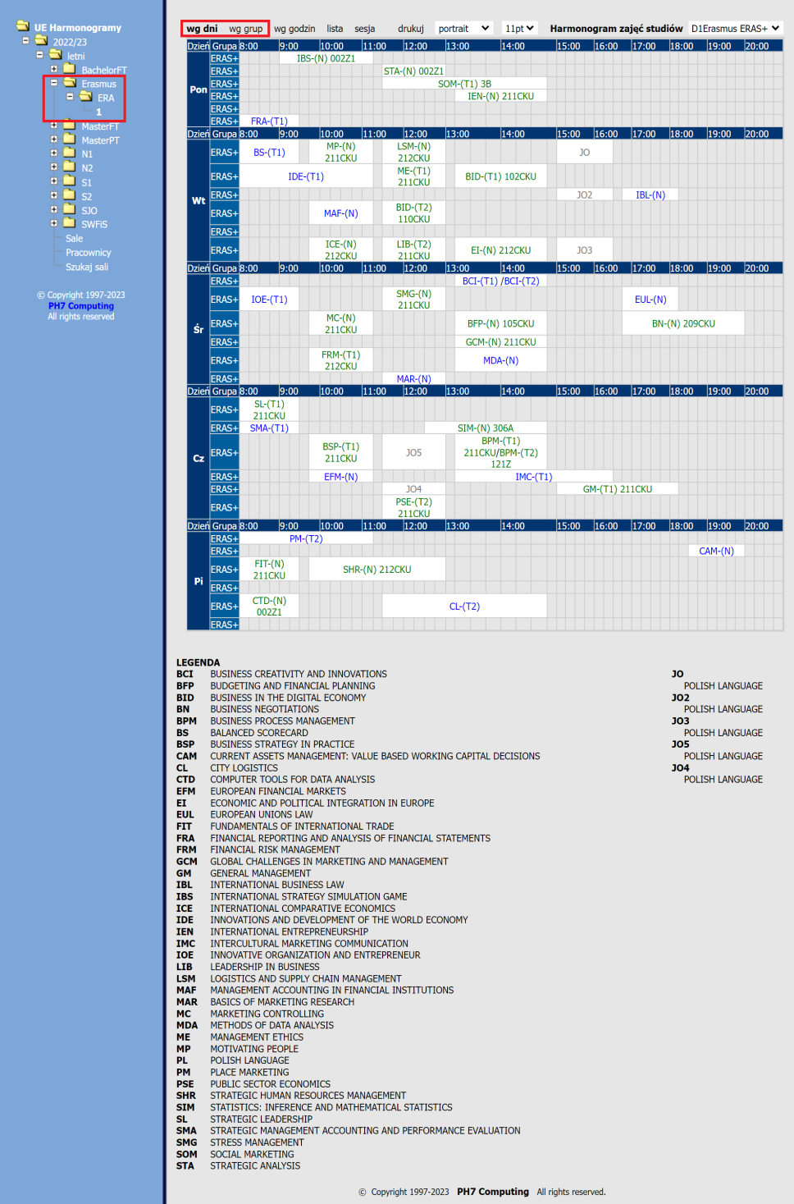Fig. 11

Additional views in the timetable

The schedule also allows you to search the timetable for a selected teaching room and for a specific staff member – filter in the top right corner. (Fig. 12, Fig. 13)
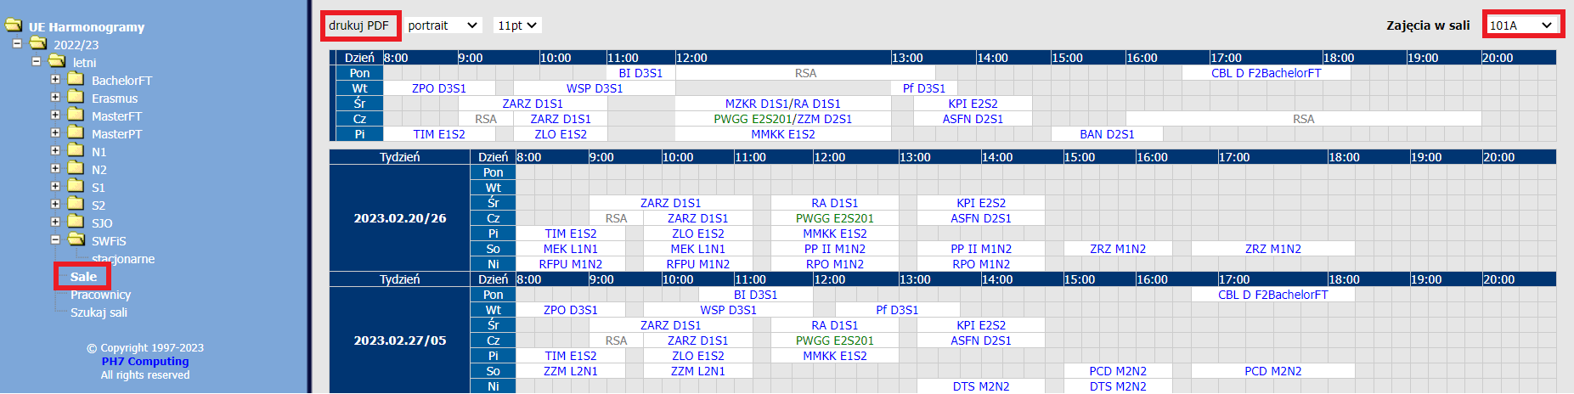 Fig. 12
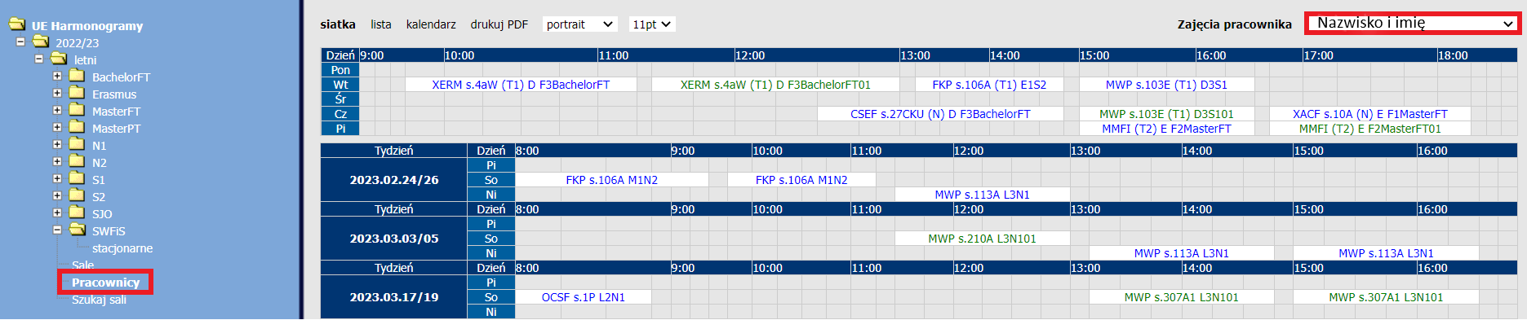Fig. 13
The timetable offers the additional functionality of search for a room on a specific day along with its attributes. (Fig. 14)
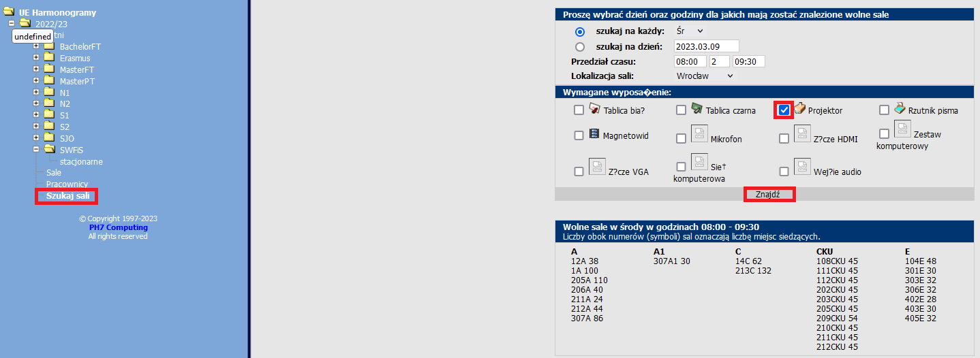 Fig. 14

How to print the timetable
The system allows you to print the timetable in the selected view. To do this, use the “drukuj” button in the top panel. (Fig. 15)
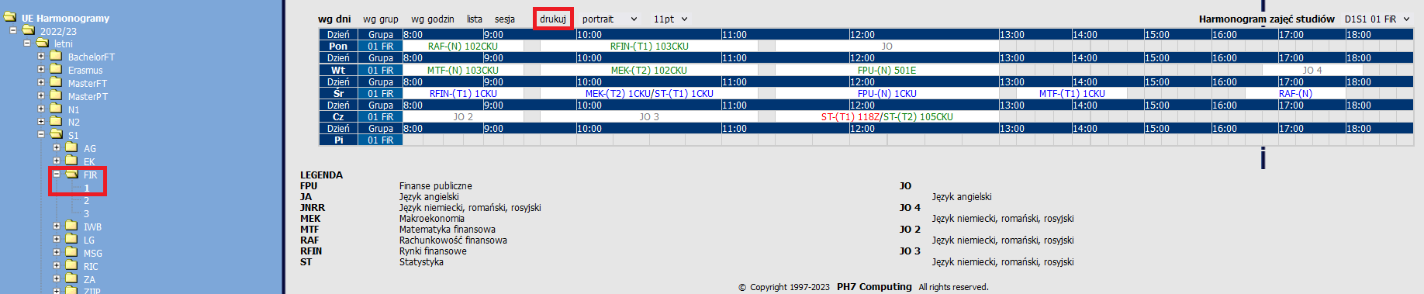Fig. 15
The figure shows the generated timetable for the selected group, ready for printing. (Fig. 16)
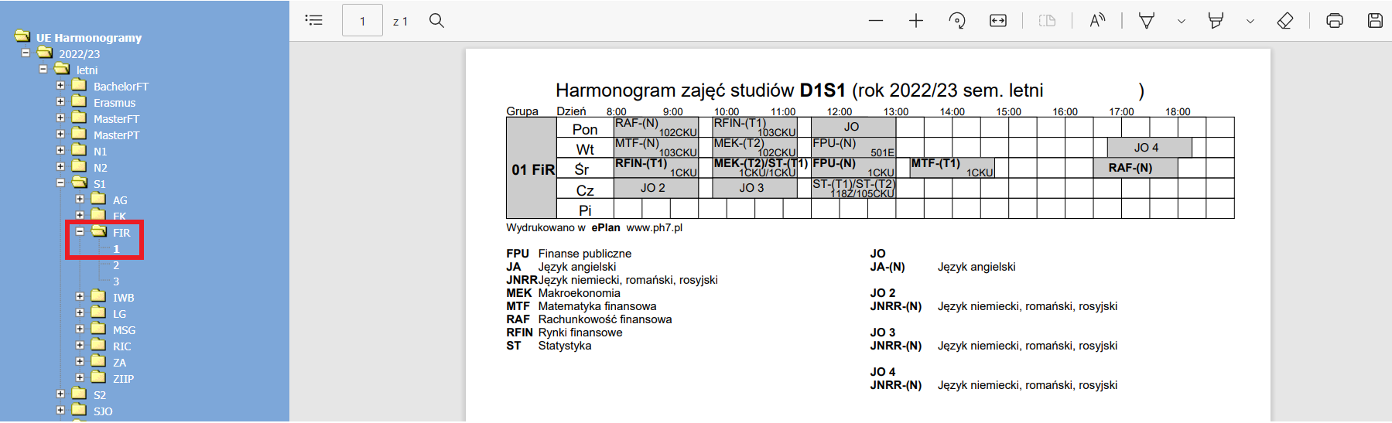Fig. 16

